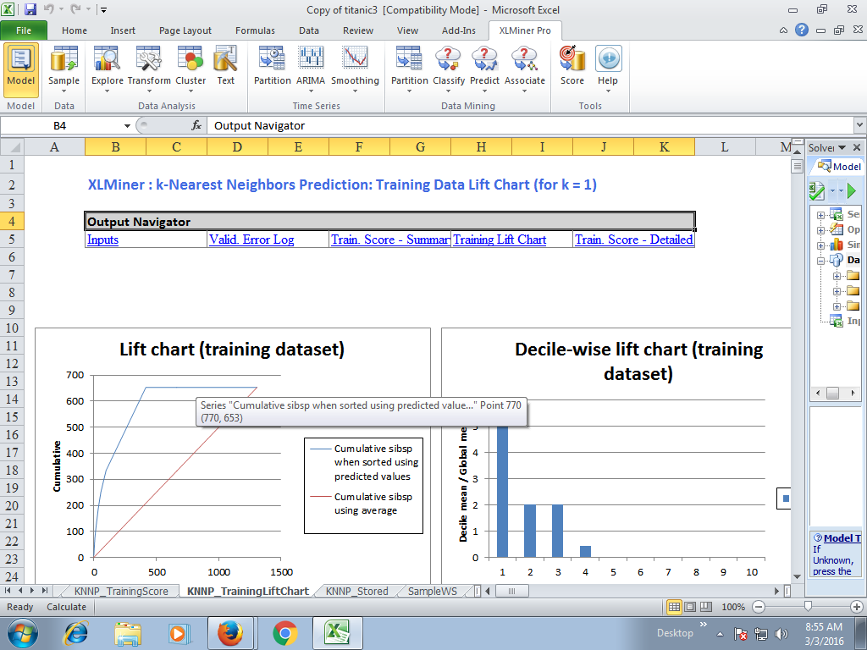

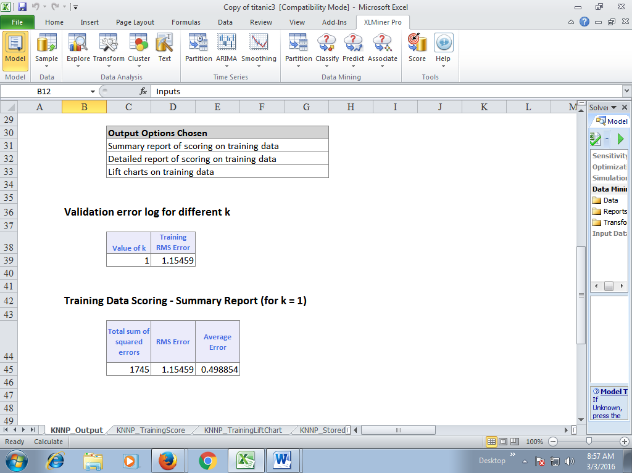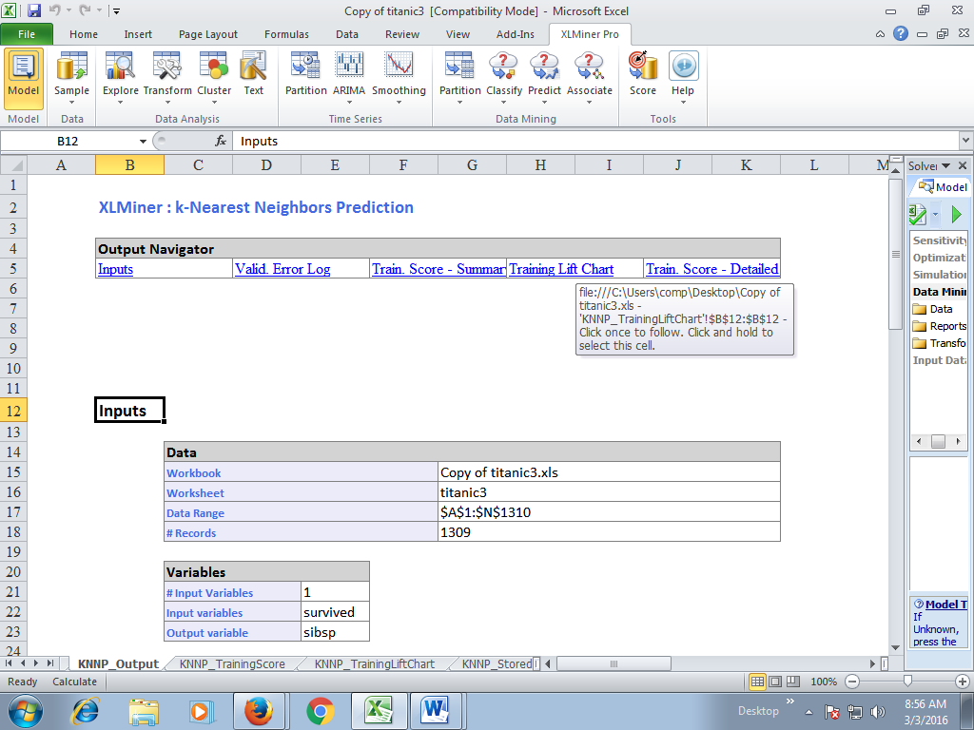

|  |  |  |  |  |  |  |  |  |  |  |
| --- | --- | --- | --- | --- | --- | --- | --- | --- | --- | --- |
|  |  | |  | |  | |  | |  | |
|  | Date: 03-Mar-2016 08:54:56 | | | | | |  | |  | |
|  |  | |  | |  | |  | |  | |
|  | **Elapsed Times in Milliseconds** | | | | | | | |  | |
|  | **Reading Data** | | **Computation** | | **Writing Data** | | **Total** | |  | |
|  | 0 | | 141 | | 15 | | 156 | |  | |
|  |  | |  | |  | |  | |  | |
|  |  | |  | |  | |  | |  | |
|  |  | |  | |  | |  | |  | |
|  |  |  | |  | |  | |  | |  | |  |  |  |  |
|  | **Inputs** |  | |  | |  | |  | |  | |  |  |  |  |
|  |  |  | |  | |  | |  | |  | |  |  |  |  |
|  |  | **Data** | | | | | | | | | | | | | |
|  |  | **Workbook** | | | | | | | | Copy of titanic3.xls | | | | | |
|  |  | **Worksheet** | | | | | | | | titanic3 | | | | | |
|  |  | **Data Range** | | | | | | | | $A$1:$N$1310 | | | | | |
|  |  | **# Records** | | | | | | | | 1309 | | | | | |
|  |  |  | |  | |  | |  | |  | |  |  |  |  |
|  |  | **Variables** | | | | | |  | |  | |  |  |  |  |
|  |  | **# Input Variables** | | | | 1 | |  | |  | |  |  |  |  |
|  |  | **Input variables** | | | | survived | |  | |  | |  |  |  |  |
|  |  | **Output variable** | | | | sibsp | |  | |  | |  |  |  |  |
|  |  |  | |  | |  | |  | |  | |  |  |  |  |
|  |  | **Parameters/Options** | | | | | | | | | | | |  |  |
|  |  | **Normalize Input Data** | | | | | | No | | | | | |  |  |
|  |  | **Number of Nearest Neighbors (k)** | | | | | | 1 | | | | | |  |  |
|  |  | **Score On** | | | | | | Specified k (1) | | | | | |  |  |
|  |  |  | |  | |  | |  | |  | |  |  |  |  |
|  |  | **Output Options Chosen** | | | | | | | | | |  |  |  |  |
|  |  | Summary report of scoring on training data | | | | | | | | | |  |  |  |  |
|  |  | Detailed report of scoring on training data | | | | | | | | | |  |  |  |  |
|  |  | Lift charts on training data | | | | | | | | | |  |  |  |  |
|  |  |  | |  | |  | |  | |  | |  |  |  |  |
|  |  |  | |  | |  | |  | |  | |  |  |  |  |
|  | **Validation error log for different k** | | | | | | |  | |  | |  |  |  |  |
|  |  |  | |  | |  | |  | |  | |  |  |  |  |
|  |  | **Value of k** | | **Training RMS Error** | |  | |  | |  | |  |  |  |  |
|  |  | 1 | | 1.15459 | |  | |  | |  | |  |  |  |  |
|  |  |  | |  | |  | |  | |  | |  |  |  |  |
|  |  |  | |  | |  | |  | |  | |  |  |  |  |
|  | **Training Data Scoring - Summary Report (for k = 1)** | | | | | | | | | | |  |  |  |  |
|  |  |  | |  | |  | |  | |  | |  |  |  |  |
|  |  | **Total sum of squared errors** | | **RMS Error** | | **Average Error** | |  | |  | |  |  |  |  |
|  |  | 1745 | | 1.15459 | | 0.498854 | |  | |  | |  |  |  |  |
|  |  |  | |  | |  | |  | |  | |  |  |  |  |
|  |  |  | |  | |  | |  | |  | |  |  |  |  |
|  |  |  | |  | |  | |  | |  | |  |  |  |  |
|  |  |  | |  | |  | |  | |  | |  |  |  |  |
|  |  |  | |  | |  | |  | |  | |  |  |  |  |
|  |  | |  |  |  |  |  |  |  |  | | --- | --- | --- | --- | --- | --- | --- | --- | |  |  |  |  |  |  |  |  | |  |  |  |  |  |  |  |  | |  | **Model** | k-Nearest Neighbors Classification |  | **Variables** | survived | sibsp |  | |  | **# Selected Variables** | 2 |  | **Variables Role** | Input | Output |  | |  | **Normalize Inputs** | FALSE |  |  |  |  |  | |  | **# Nearest Neighbors** | 1 |  |  |  |  |  | |  | **Best K** | 1 |  |  | **survived** | **sibsp** |  | |  | **Selected Variables** | F3:G3 |  |  | 1 | 0 |  | |  | **Variable Role** | F4:G4 |  |  | 1 | 1 |  | |  | **Model Data** | F8:G1316 |  |  | 0 | 1 |  | |  | **Output Column** | 2 |  |  | 0 | 1 |  | |  | **Scoring Type** | 0 |  |  | 0 | 1 |  | |  |  |  |  |  | 1 | 0 |  | |  |  |  |  |  | 1 | 1 |  | |  |  |  |  |  | 0 | 0 |  | |  |  |  |  |  | 1 | 2 |  | |  |  |  |  |  | 0 | 0 |  | |  |  |  |  |  | 0 | 1 |  | |  |  |  |  |  | 1 | 1 |  | |  |  |  |  |  | 1 | 0 |  | |  |  |  |  |  | 1 | 0 |  | |  |  |  |  |  | 1 | 0 |  | |  |  |  |  |  | 0 | 0 |  | |  |  |  |  |  | 0 | 0 |  | |  |  |  |  |  | 1 | 0 |  | |  |  |  |  |  | 1 | 0 |  | |  |  |  |  |  | 0 | 0 |  | |  |  |  |  |  | 1 | 1 |  | |  |  |  |  |  | 1 | 1 |  | |  |  |  |  |  | 1 | 0 |  | |  |  |  |  |  | 1 | 0 |  | |  |  |  |  |  | 1 | 0 |  | |  |  |  |  |  | 0 | 0 |  | |  |  |  |  |  | 1 | 1 |  | |  |  |  |  |  | 1 | 1 |  | |  |  |  |  |  | 1 | 0 |  | |  |  |  |  |  | 1 | 0 |  | |  |  |  |  |  | 0 | 0 |  | |  |  |  |  |  | 1 | 0 |  | |  |  |  |  |  | 1 | 0 |  | |  |  |  |  |  | 1 | 0 |  | |  |  |  |  |  | 0 | 0 |  | |  |  |  |  |  | 1 | 0 |  | |  |  |  |  |  | 1 | 0 |  | |  |  |  |  |  | 1 | 0 |  | |  |  |  |  |  | 0 | 0 |  | |  |  |  |  |  | 0 | 0 |  | |  |  |  |  |  | 0 | 0 |  | |  |  |  |  |  | 1 | 0 |  | |  |  |  |  |  | 1 | 2 |  | |  |  |  |  |  | 1 | 0 |  | |  |  |  |  |  | 1 | 0 |  | |  |  |  |  |  | 0 | 0 |  | |  |  |  |  |  | 0 | 0 |  | |  |  |  |  |  | 1 | 0 |  | |  |  |  |  |  | 1 | 0 |  | |  |  |  |  |  | 1 | 0 |  | |  |  |  |  |  | 1 | 0 |  | |  |  |  |  |  | 0 | 0 |  | |  |  |  |  |  | 0 | 0 |  | |  |  |  |  |  | 0 | 0 |  | |  |  |  |  |  | 1 | 1 |  | |  |  |  |  |  | 1 | 1 |  | |  |  |  |  |  | 1 | 1 |  | |  |  |  |  |  | 1 | 1 |  | |  |  |  |  |  | 0 | 0 |  | |  |  |  |  |  | 1 | 0 |  | |  |  |  |  |  | 0 | 1 |  | |  |  |  |  |  | 1 | 1 |  | |  |  |  |  |  | 0 | 1 |  | | |  | |  | |  | |  | |  |  |  |  |

